Report of One - Day Workshop on Spoken English

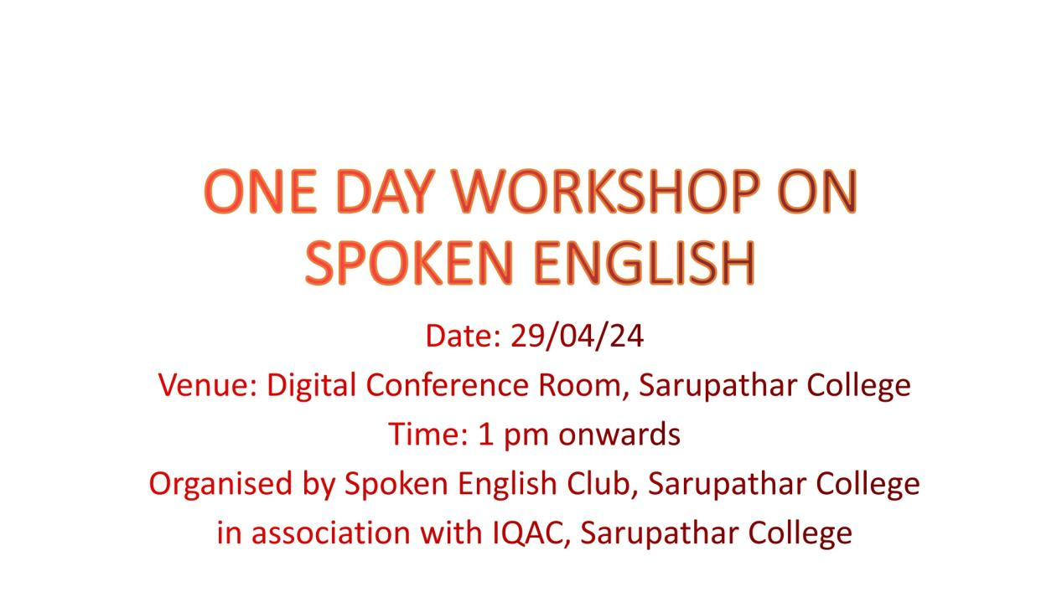

Realizing the relevance of English language in connecting, generating and disseminating of knowledge, the Spoken English Club, in association with IQAC of Sarupathar College has organised a One-Day workshop on Spoken English.The programme was hosted by Mrs. Jerry Timungpi,coordinator, Spoken English Club.The programme began with an inaugural speech by the coordinator, followed by self introduction of participants. To promote fluency in English language among students, the coordinator stressed on the importance of English language. She shared her thoughts on the importance of language and communication skills for expression and articulation of one’s ideas.She also highlighted on the ways to overcome shyness and develop strong attitude regarding the use and command of the language. To make the session more interesting and interactive, an activity was given to the students. Each student was given the opportunity to choose a topic and express their views for a minimum of three minutes. All the participants participated in the activity very enthusiastically.Ashmita Dhar and Shingle Rengma from B.A 4th semester managed to get 1st and 2nd position in the activity. Towards the end of the programme, the students thanked the Coordinator for providing them such an insightful and encouraging session. The session ended with a vote of thanks by the coordinator.

**Glimpses from the session**

